There was once a group of unlikely friends who lived on a tropical island. This island had beautiful mountains full of palm trees. You could feel and hear the warm tropical breezes blowing all day long.

Assume MOUNTAIN POSE (feet apart with arms by your side) raise your arms up slowly as you breath in through your nose; bring your arms down slowly as you breath out through your mouth – 3 times.
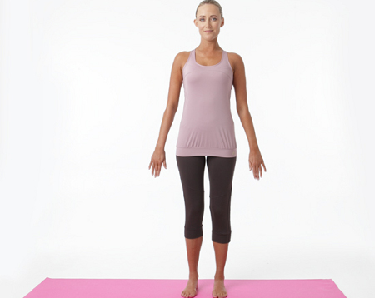

These friends included a cat named__________________.

Assume CATS POSE (on hands and knees, lower your head, raise your back up into the air and breath in through your nose) and then COW POSE (raise your head, lower your back and breath out through your mouth 5 times slowly.

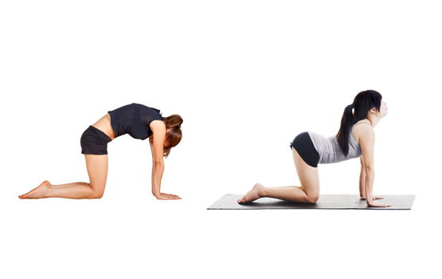

And a cobra named _____________________.

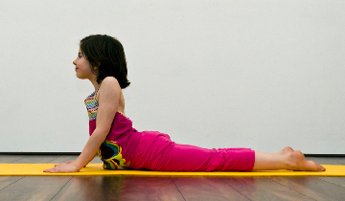

Assume COBRA Pose. Drop gently down onto your stomach and push up from your hands so that your elbows are almost straight. Breath in through your nose and out through your mouth 3 times.

And a dog named _________________.
Raise your hips high into the air; with your hands and feet as flat on the ground as is comfortable and your arms and legs as straight as is comfortable. This is DOWNWARD DOG. Breath in through your nose and out through your mouth 3 times.

These three were friends, who tried to always be nice to everyone, like bucket fillers. When they were thinking unkind thoughts they kept them to themselves. They helped each other find food and fend off attacks. When they were in dangerous situations and had to defend themselves they would assume a WARRIOR POSITION to let everyone know that they were strong physically and had a strong, positive spirit. Assume warrior position by standing with your feet apart; turn one foot so it is facing forward, raise your arms to shoulder with your elbows straight, and lean/lunge slowly on the foot that is pointing forward so that your knee bends. Breath in through your nose and out through your mouth slowly 3x. Switch legs and repeat.

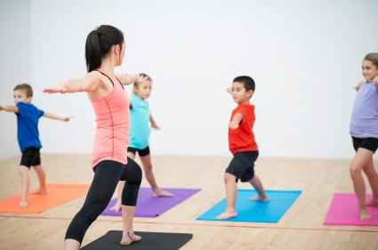

One day the sky filled with dark, gray clouds and the wind started to howl. The trees began to sway back and forth.

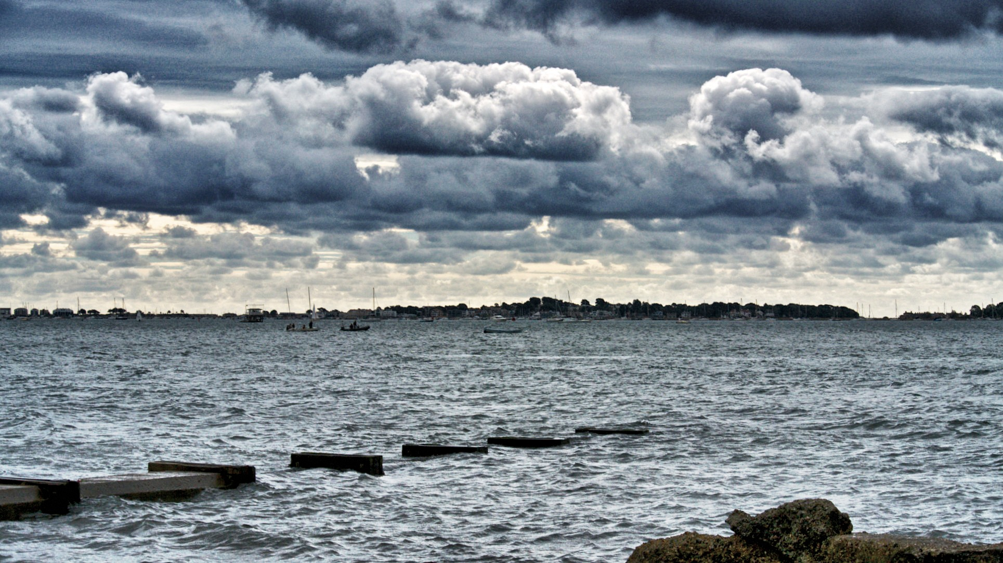

Assume TREEPOSE in groups/clusters. (Raise one leg up so that your foot either rests on: your ankle, right below your knee or right above your knee.) Place your hands on your neighbors shoulders and help each other to keep your balance. Breath in through your nose slowly and out through your mouth slowly 5x and then switch legs and repeat.
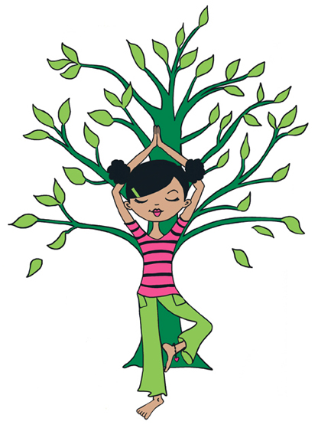

The three friends had helped each other stay safe through the storm. They had gone into a cave and assumed CHILD’S POSE (kneel on the floor and bring your head down to the floor with your arms straight out in front of you on the floor) and breathed 5 times slowly in through your nose and slowly out through your mouth) to relax all the body so that they wouldn’t be afraid.
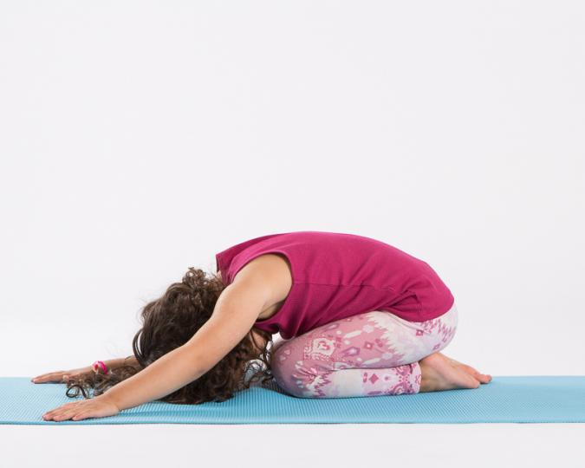

It rained for many hours. Then finally it stopped raining; the sun came out and with it was a beautiful rainbow.

Assume RAINBOW POSE ( get on your knees and bring one arm up and over your head). Breath in through your nose slowly and out through your mouth slowly 5 times and then switch arms and repeat.

And because these friends had tried to always have a positive attitude throughout their whole lives they were able to weather any storm in their lives.

I HOPE YOU DO THE SAME!!!!!!

